Assignment- 4

UltrasonicsensorsimulationinWokwi

|  |  |
| --- | --- |
| AssignmentDate | 24October2022 |
| StudentName | Sakthisugesh .B.R |
| StudentRollNumber | 6113192071074 |
| MaximumMarks | 2Marks |

**Question-1:**

Writeacodeandconnectionsinwokwifortheultrasonicsensor.Wheneverthedistanceislessthan

100cmssendan“Alert”toIBM cloudanddisplayinthedevicerecentevents.

# Code:

#include<WiFi.h>

#include<PubSubClient.h>

voidcallback(char*subscribetopic,byte* payload,unsignedint

payloadLength);

//-------credentials of IBM Accounts------

#define ORG "ytluse"//IBM ORGANITION ID

#define DEVICE_TYPE "2702"//Device type mentioned in ibmwatson IOT Platform

#define DEVICE_ID "12345"//Device ID mentioned in ibmwatson IOT Platform

#define TOKEN "O+n)Eh+lNX0y3?rG!8"//Token

String data3;

charserver[]= ORG ".messaging.internetofthings.ibmcloud.com";

charpublishTopic[]="iot-2/evt/Data/fmt/json";

charsubscribetopic[]="iot-2/cmd/test/fmt/String";

charauthMethod[]="use-token-auth";

chartoken[]= TOKEN;

charclientId[]="d:" ORG ":" DEVICE_TYPE ":" DEVICE_ID;

WiFiClientwifiClient;

PubSubClientclient(server,1883, callback ,wifiClient);

constinttrigPin=5;

constintechoPin=18;

#define SOUND_SPEED 0.034

long duration;

float distance;

voidsetup(){

**Serial**.begin(115200);

pinMode(trigPin,OUTPUT);

pinMode(echoPin,INPUT);

wificonnect();

mqttconnect();

}

voidloop()

{

digitalWrite(trigPin,LOW);

delayMicroseconds(2);

digitalWrite(trigPin,HIGH);

delayMicroseconds(10);

digitalWrite(trigPin,LOW);

duration =pulseIn(echoPin,HIGH);

distance = duration * SOUND_SPEED/2;

**Serial**.print("Distance (cm): ");

**Serial**.println(distance);

if(distance<100)

{

**Serial**.println("ALERT!!");

delay(1000);

PublishData(distance);

delay(1000);

if(!client.loop()){

mqttconnect();

}

}

delay(1000);

}

voidPublishData(floatdist){

mqttconnect();

String payload ="{\"Distance\":";

payload +=dist;

payload +=",\"ALERT!!\":""\"Distance less than 100cms\"";

payload +="}";

**Serial**.print("Sending payload: ");

**Serial**.println(payload);

if(client.publish(publishTopic,(char*)payload.c_str())){

**Serial**.println("Publish ok");

}else{

**Serial**.println("Publish failed");

}

}

voidmqttconnect(){

if(!client.connected()){

**Serial**.print("Reconnecting client to ");

**Serial**.println(server);

while(!!!client.connect(clientId,authMethod, token)){

**Serial**.print(".");

delay(500);

}

initManagedDevice();

**Serial**.println();

}

}

voidwificonnect()

{

**Serial**.println();

**Serial**.print("Connecting to ");

WiFi.begin("Wokwi-GUEST","",6);

while(WiFi.status()!= WL_CONNECTED){

delay(500);

**Serial**.print(".");

}

**Serial**.println("");

**Serial**.println("WiFi connected");

**Serial**.println("IP address: ");

**Serial**.println(WiFi.localIP());

}

voidinitManagedDevice(){

if(client.subscribe(subscribetopic)){

**Serial**.println((subscribetopic));

**Serial**.println("subscribe to cmd OK");

}else{

**Serial**.println("subscribe to cmd FAILED");

}

}

voidcallback(char*subscribetopic,byte* payload,unsignedintpayloadLength)

{

**Serial**.print("callback invoked for topic: ");

**Serial**.println(subscribetopic);

for(inti=0;i<payloadLength;i++){

//Serial.print((char)payload[i]);

data3 +=(char)payload[i];

}

**Serial**.println("data: "+ data3);

data3="";

}

**Diagram.json:**

{

  "version":1,

  "author":"IRFANA FATHIMA A 19IT007",

  "editor":"wokwi",

  "parts":[

    {"type":"wokwi-esp32-devkit-v1","id":"esp","top":6,"left":-66,"attrs":{}},

    {"type":"wokwi-hc-sr04","id":"ultrasonic1","top":32.56,"left":81.02,"attrs":{}}

  ],

  "connections":[

    ["esp:TX0","$serialMonitor:RX","",[]],

    ["esp:RX0","$serialMonitor:TX","",[]],

    ["esp:VIN","ultrasonic1:VCC","red",["h-31.67","v-176.8","h152","v163.33"]],

    ["esp:D18","ultrasonic1:ECHO","green",["h11.37","v64.67","h121.33"]],

    ["esp:D5","ultrasonic1:TRIG","green",["h16.7","v45.07","h4"]],

    ["esp:GND.1","ultrasonic1:GND","black",["h8.7","v14.7","h138.67"]]

  ]

}

# CircuitDiagram:

# 

**Output:**

Wokwioutput:

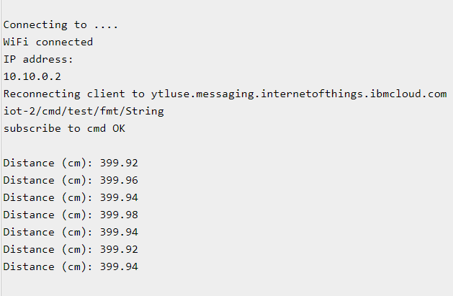

IBMcloudoutput:

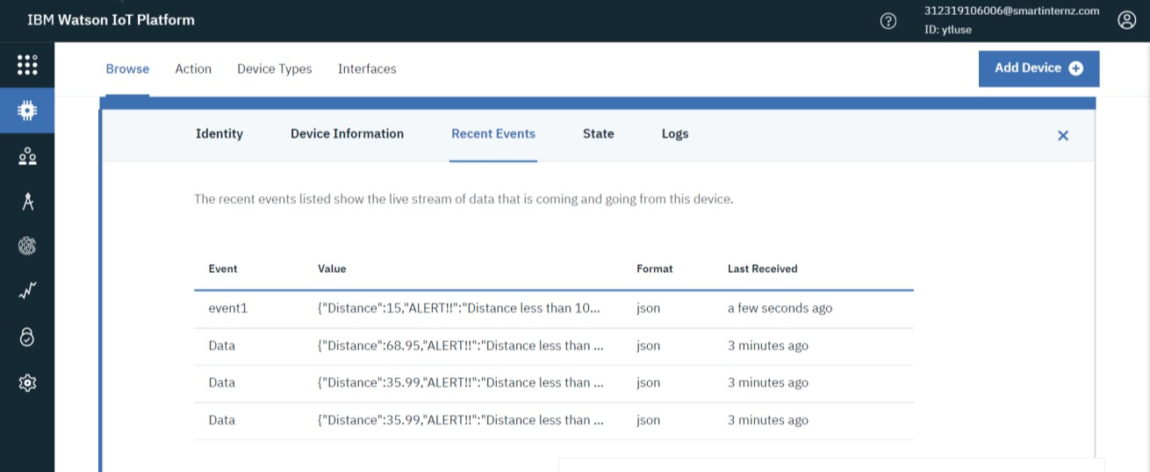

# Wokwisimulationlink:

<https://wokwi.com/projects/346458884229038675>